Multiple Choice Questions:
1. Which of Newton's Laws of Motion is called the Law of Inertia?
A) 2nd
B) 3rd
C) 1st

2. Which of Newton's Laws of Motion states that objects at rest tend to to stay at rest and objects in motion tend to stay in motion unless acted upon by unbalanced force?
A) 2nd
B) 3rd
C) 1st

3. The tendency of a moving object to continue in a straight line or a stationary object to remain in place is called -remain in place is called -
A) reaction
B) inertia
C) action
D) force

4. Which of Newton's Laws of Motion states that force equals mass Which of Newton's Laws of Motion states that force equals mass times acceleration?
A) 2nd
B) 1st
C) 3rd

5. According to Newton's 2nd Law of Motion, force equals -According to Newton's 2nd Law of Motion, force equals -
A) mass subtract acceleration
B) mass divided by acceleration
C) mass plus acceleration
D) mass times acceleration

6. Which of Newton's Laws of Motion states that for every action, there is an equal and opposite reaction?
A) 2nd
B) 1st
C) 3rd

7. Which of the following is defined as a push or a pull?
A) acceleration
B) mass
C) deceleration
D) force
8. When a teacher stands at the front of the class, the force of gravity pulls her toward the ground. The ground pushes back with an equal and opposite force. force. This is an example of which of Newton's Laws of Motion?
A) 2nd
B) 1st
C) 3rd

9. Push or pull that causes an object to move, stop or change direction
A) force
B) gravitation
C) friction
D) work

10. Use the force to move an object through a distance
A) friction
B) gravitation
C) magnetism
D) work
E) force

11. Force that pulls all objects toward each other
A) magnetism
B) gravitation
C) work
D) force
E) friction
12. Which of the following is not a force?
A) friction
B) newton
C) gravity
D) magnetism

13. The first law of motion says that an object at rest will remain at rest unless ________
A) a nearby star acts on it
B) an outside force act on it
C) it is placed on a flat surface
D) it continues in a straight line

14. According to the third law of motion, for every action there is _________
A) a greater force pushing on it
B) a force sending it backward
C) an equal and opposite reaction
D) a movement in all directions
15. What do the laws of motion explain?
A) the relationship between the four basic elements
B) The movement of objects on Earth and in space
C) Why all moving objects eventually stop moving
D) how frame of reference influences movement

16. A change to an objects motion is caused by...
a. Balanced forces
b. Unbalanced forces
c. Acceleration
d. Velocity

17. Which one of the following objects has the greatest inertia?
a. ping pong ball
b. a golf ball
c. a soft ball
d. a bowling ball

18. Describe the motion of a person not wearing a seat belt if the car stops suddenly.
a. The person and car will stop together.
b. The person will stop faster than the car because they are lighter.
c. The car will stop and the person will keep moving forward because of inertia.
d. The car will stop and the person will speed up.

19. What forces are acting on a dropped book that falls to the floor?
a. Gravity only
b. Gravity and air resistance
c. Air resistance
d. Friction only

20. Forms of energy
a. Potential and Kinetic
b. Mechanical and Chemical
c. Light and Thermal
d. Electrical and Nuclear
e. all of the above

21. Average speed is equal to ________
- distance/time
- time/distance
- distance + time
- distance * time

22. What does Newton's first law of motion state?
- An object in motion stays in motion unless a force acts on it.
- An object's acceleration (change in speed) depends on the mass of the object and the amount of force applied on it.
- An object at rest stays at rest unless a force acts on it.
- Every action has an equal and opposite reaction.
- Both A and C

23. Tulene is walking to school. It took her 4 minutes to walk 160 feet. How fast was she walking?
- 100 feet per mile
- 40 feet per minute
- 50 feet per mile
- 100 miles per hour

24. The tendency of an object to remain at rest or in motion is .
- friction
- velocity
- acceleration
- inertia

25. This type of force affects two objects that are touching each other.
- net
- friction
- gravity
- newtons

26. Two forces working in opposite directions, each with a force of 20 N, are .
- balanced
- unbalanced
- uneven
- different

27. To describe the motion of an object, you need to know ____________.
- the unit of mass
- a reference point
- the unit of temperature
- its size

28. Velocity is a measure of speed that takes into account the
- weight of an object.
- direction of movement.
- force of the movement.
- acceleration of an object.

29. In order for an object to begin to move, stop moving, or change direction, which of the following must be present?
- unbalanced force
- friction force
- balanced force
- none of the above

30. If gravitation suddenly stopped, Earth would move .
- in orbit with the Sun
- in the opposite direction
- nowhere
- in a straight line

31. Forces that delete the effect of each other are called _______ forces.
- unbalanced
- balanced
- zero
- many

Name the following Energy:
- Energy that moves object from place to place
- Energy released by a chemical reaction
- Energy that comes from the electrons within atoms
- Energy created by the motion of atoms and molecules that occurs within an object.
- Energy contained in the nucleus of an atom.
- Energy that can move through empty space.

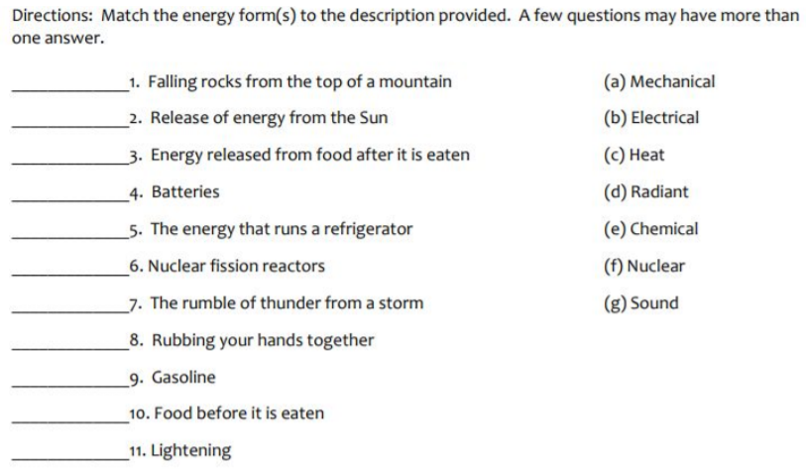
True/False
1. Electrical currents are examples of non-contact forces.
- True
- False

2 Acceleration is the result of unbalanced forces acting on an object.
- True
- False

3. Pressure results from a force pressing on an area.
- True
- False

4. In order to calculate speed, you need to know distance and area.
- True
- False

5. Your weight is constant everywhere in the universe.
- True
- False

6. As the mass of an object decreases, its gravitational force increases.
- True
- False

7. Newton's law of universal gravitation states that an object in motion will stay in motion unless acted on by a force.
- True
- False

8. Motion is measured in relation to a point of reference.
- True
- False

